 

**Placement Empowerment Program**  
**Cloud Computing and DevOps Centre**

## **Automating File Copying with a Script**

**Name:** Jeslin Anista J  
**Department:** EEE



## **Introduction and Overview**

This POC demonstrates how to automate file copying using a script. By following these steps, you will gain hands-on experience in scripting and task automation, essential skills in DevOps and cloud computing.

## **Objective**

1. Create a script to copy files from one directory to another.
2. Automate the process to run at scheduled intervals.
3. Verify successful file transfer.

## **Importance of Automation**

* **Efficiency:** Reduces manual effort in file management.
* **Consistency:** Ensures files are copied without errors.
* **Scalability:** Automates repetitive tasks for large-scale operations.

## **Step-by-Step Instructions**

### ****Step 1:**** Create two folders named Source and Destination



Store some files inside it to automate it

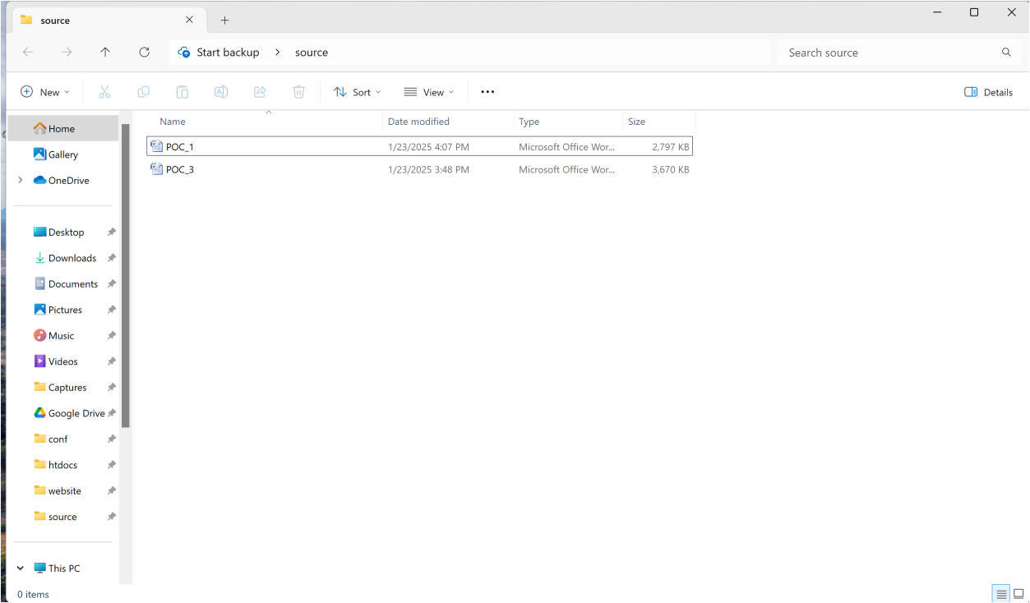

* hit Enter.
* On Linux/macOS, open the Terminal application.

### ****Step 2:**** ****Create the Script****

* Open a text editor (Notepad, VS Code, or Nano).
* Write the following script: 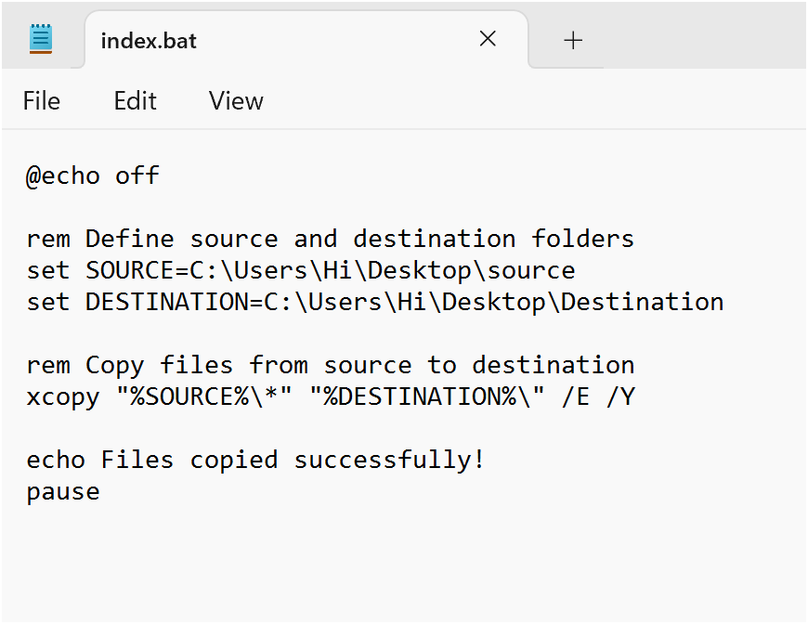

### ****Step 3: Save the Script****

* Save as copy_files.bat (Windows) or copy_files.sh (Linux/macOS).



### ****Step 4: Run the Script****

* On Windows, double-click copy_files.bat or run:
* copy_files.bat
* Press **Win + R** on your keyboard.

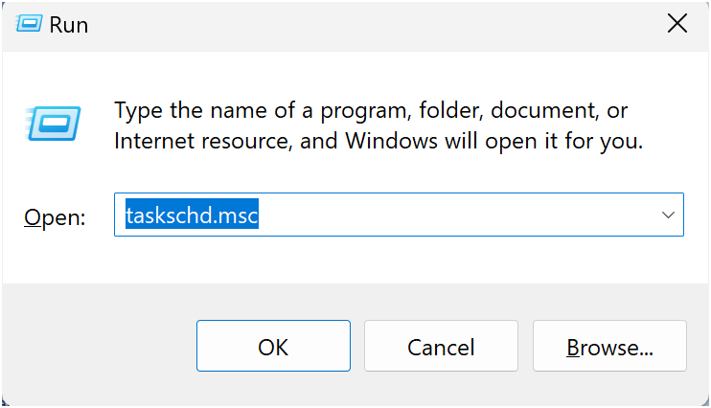

* On Linux/macOS, give execute permission and run: 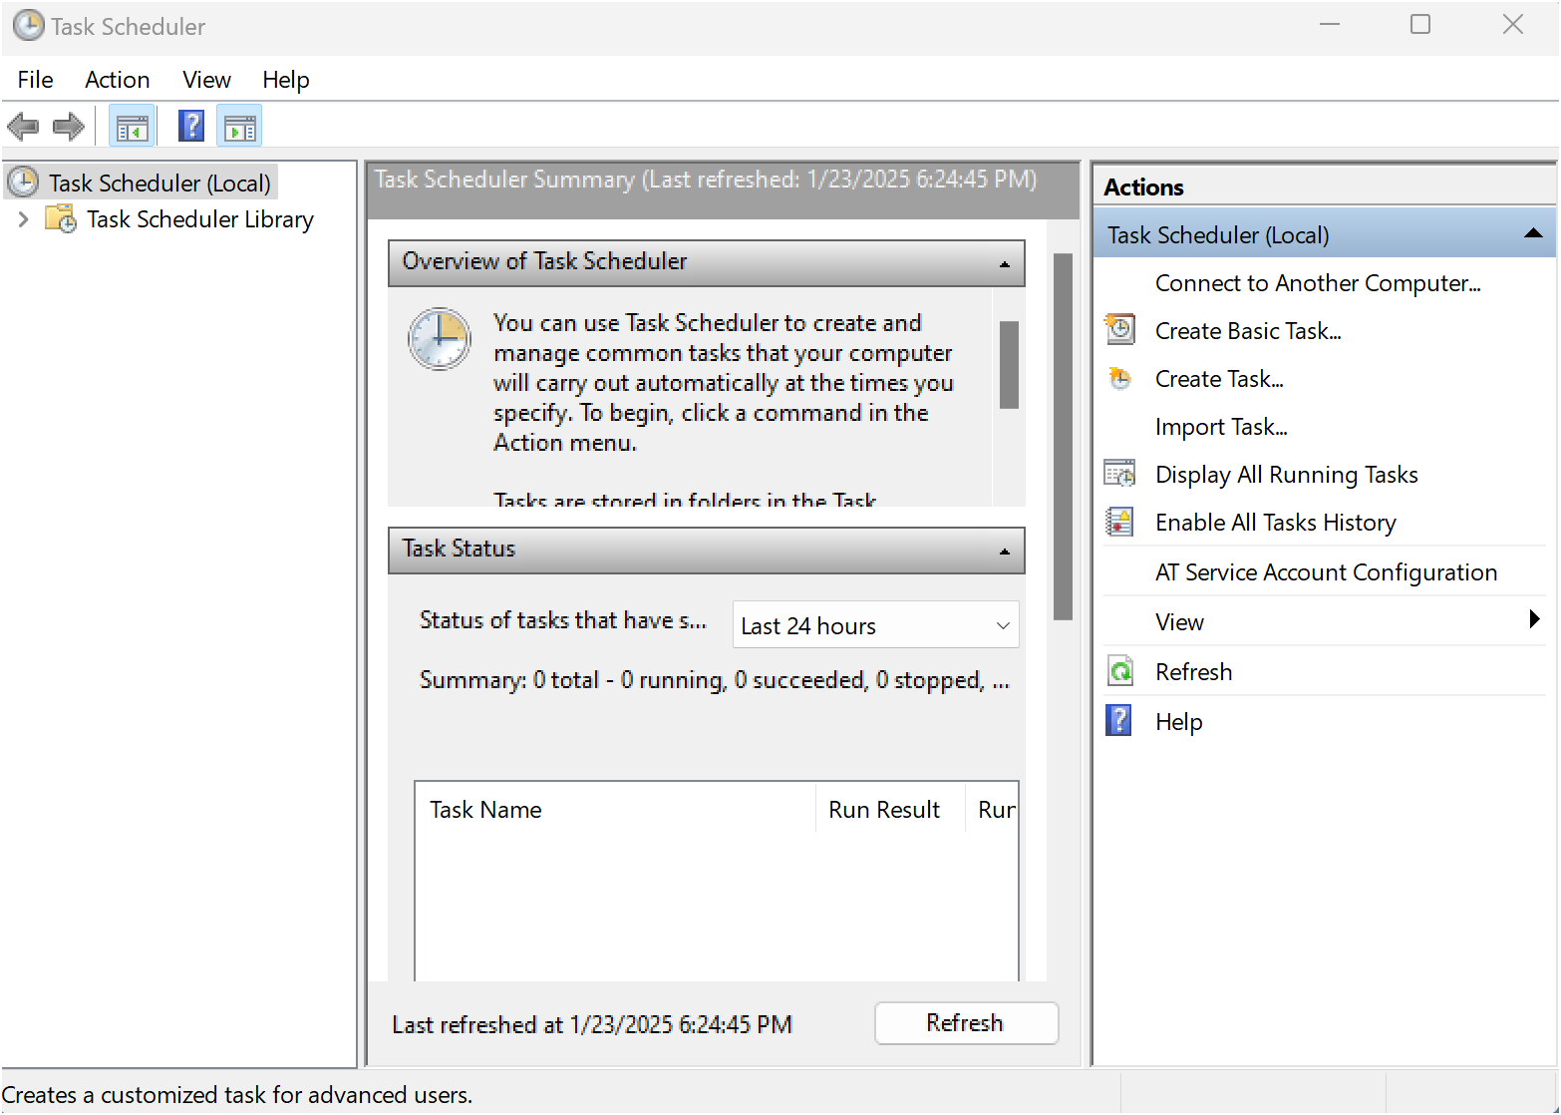
* chmod +x copy_files.sh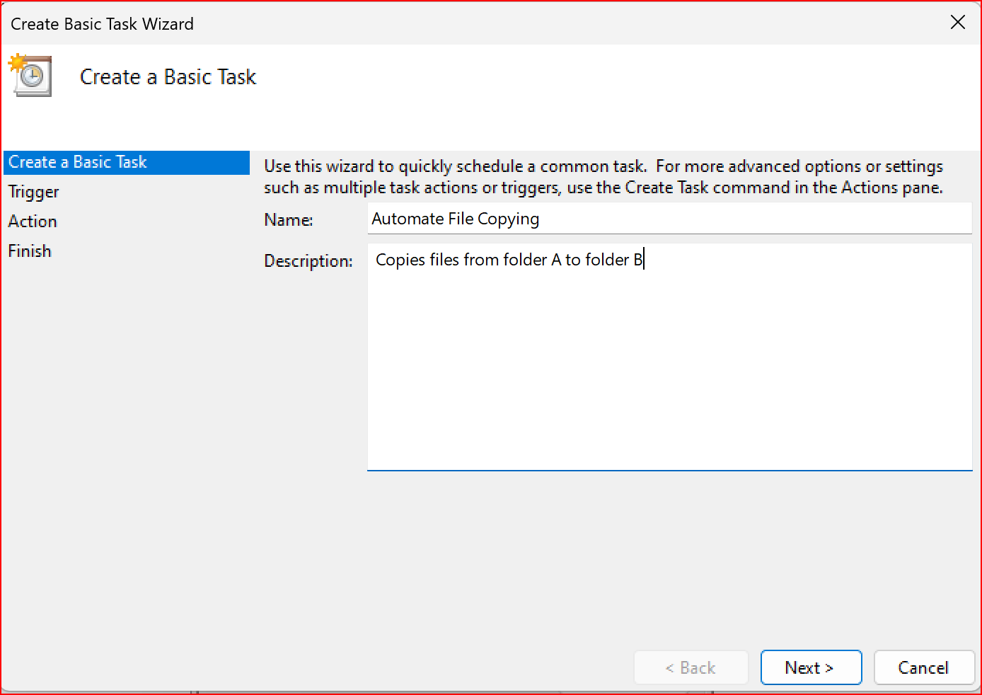
* ./copy_files.sh
* **Step 5: Choose a Schedule:**

You will see options like:

Daily (runs every day).

Weekly (runs once a week).

One time (runs only once at a specific time).

Choose what works for you (e.g., Daily) and click Next.

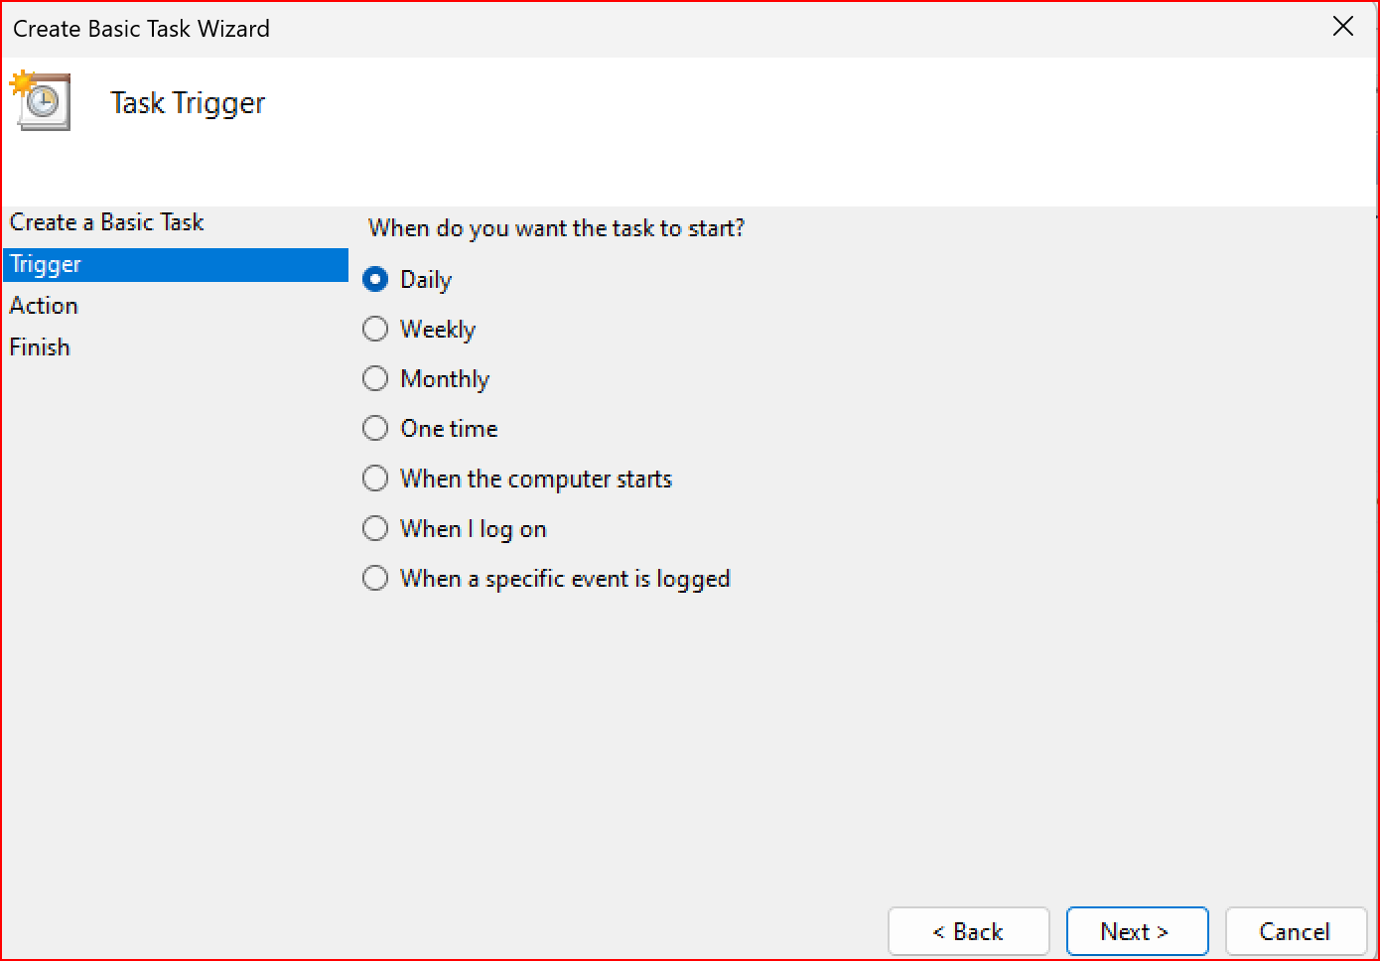

* **Step 6: Set the Time and Frequency:**

If you chose Daily, specify:

The start date (it defaults to today).

The time (e.g., 10:00 AM).

Click Next to move on.

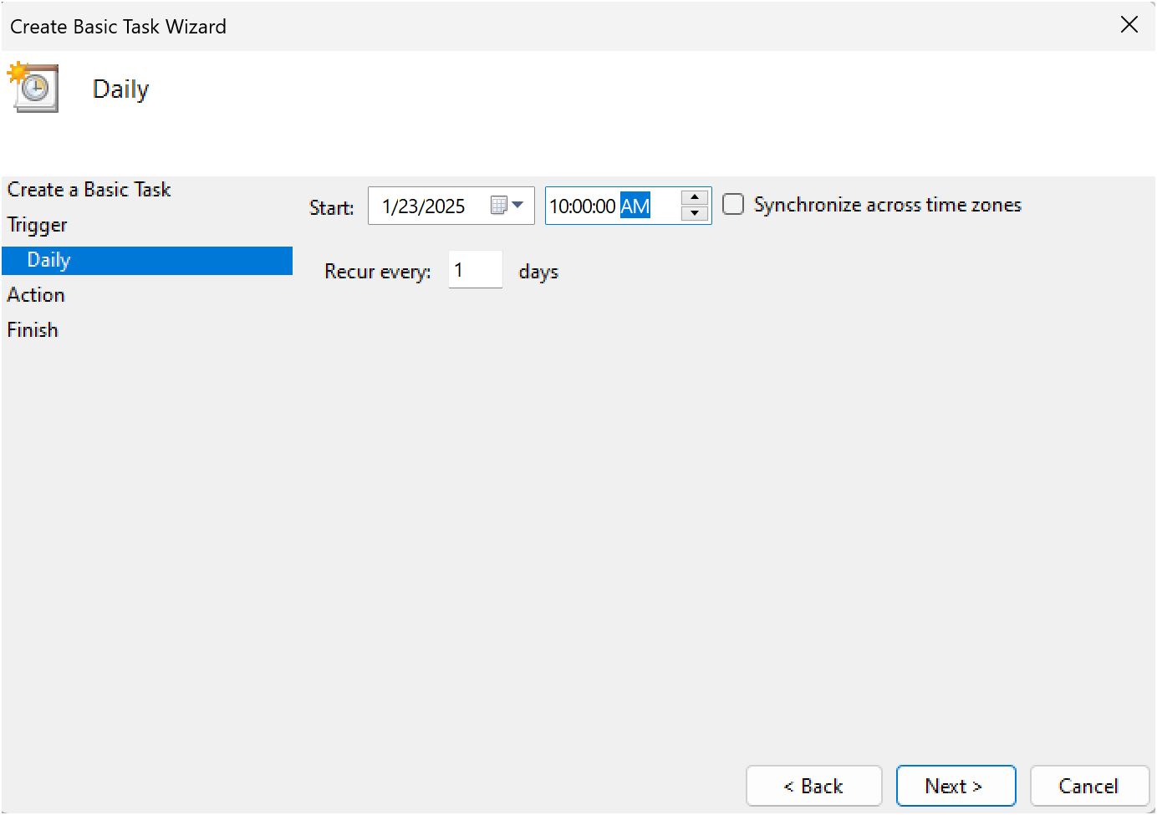

* **Step 7 : Set the Action**

Now, we tell Task Scheduler what to do when it runs.

Select "Start a Program": On the "Action" screen, select the option **"**Start a Program**"**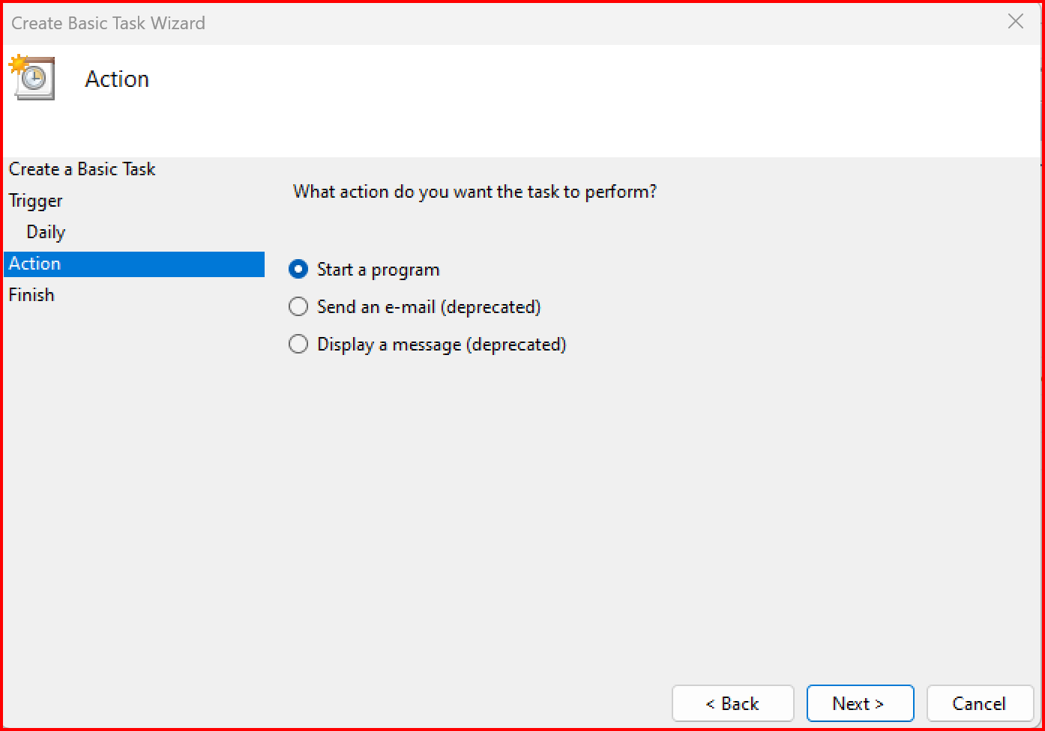

* **Step 8: Point to the Program or Script:**

In the Program/script field, click **Browse** and navigate to the location of your .bat file.

Example: If your script is named index.bat and saved on the desktop, navigate to that file and select it.

Click Next.

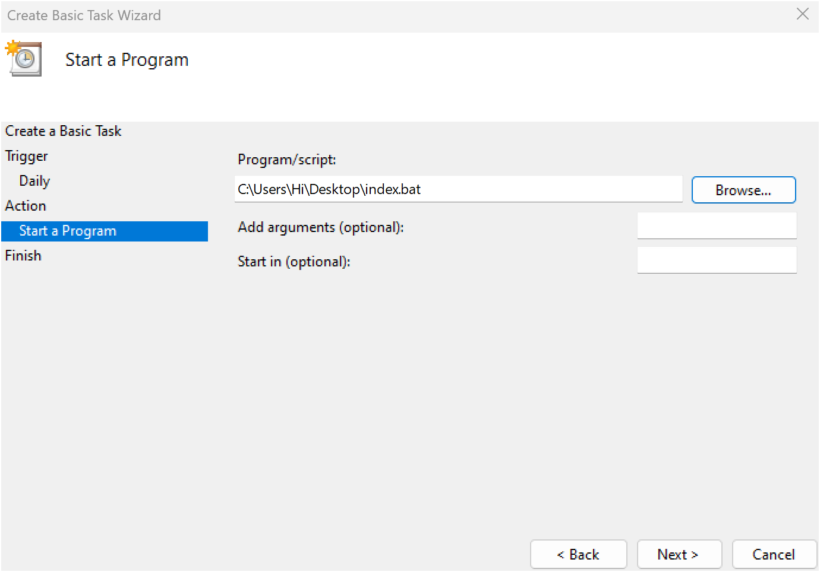

* **Step 9 : Review and Finish**

Click **Finish** to save and schedule the task.

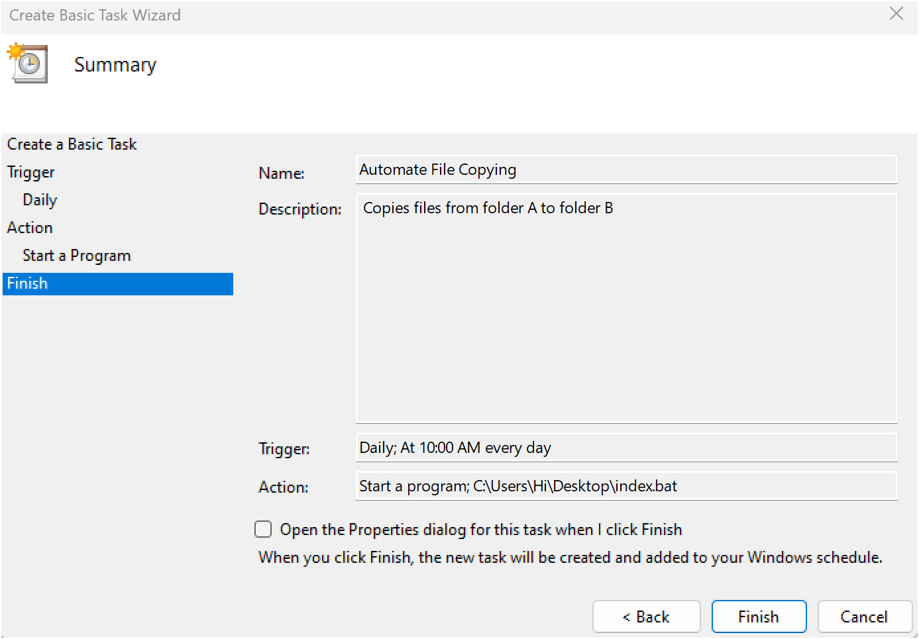

In Task Scheduler, go to the **Task Scheduler Library** (on the left-hand side).

Find your task (it should have the name you gave it, e.g., "Automate File Copying").

Right-click the task and select **Run**.

This will manually trigger the task immediately.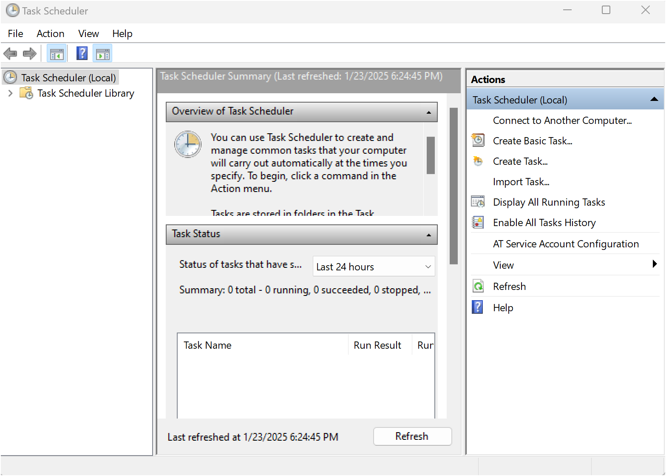

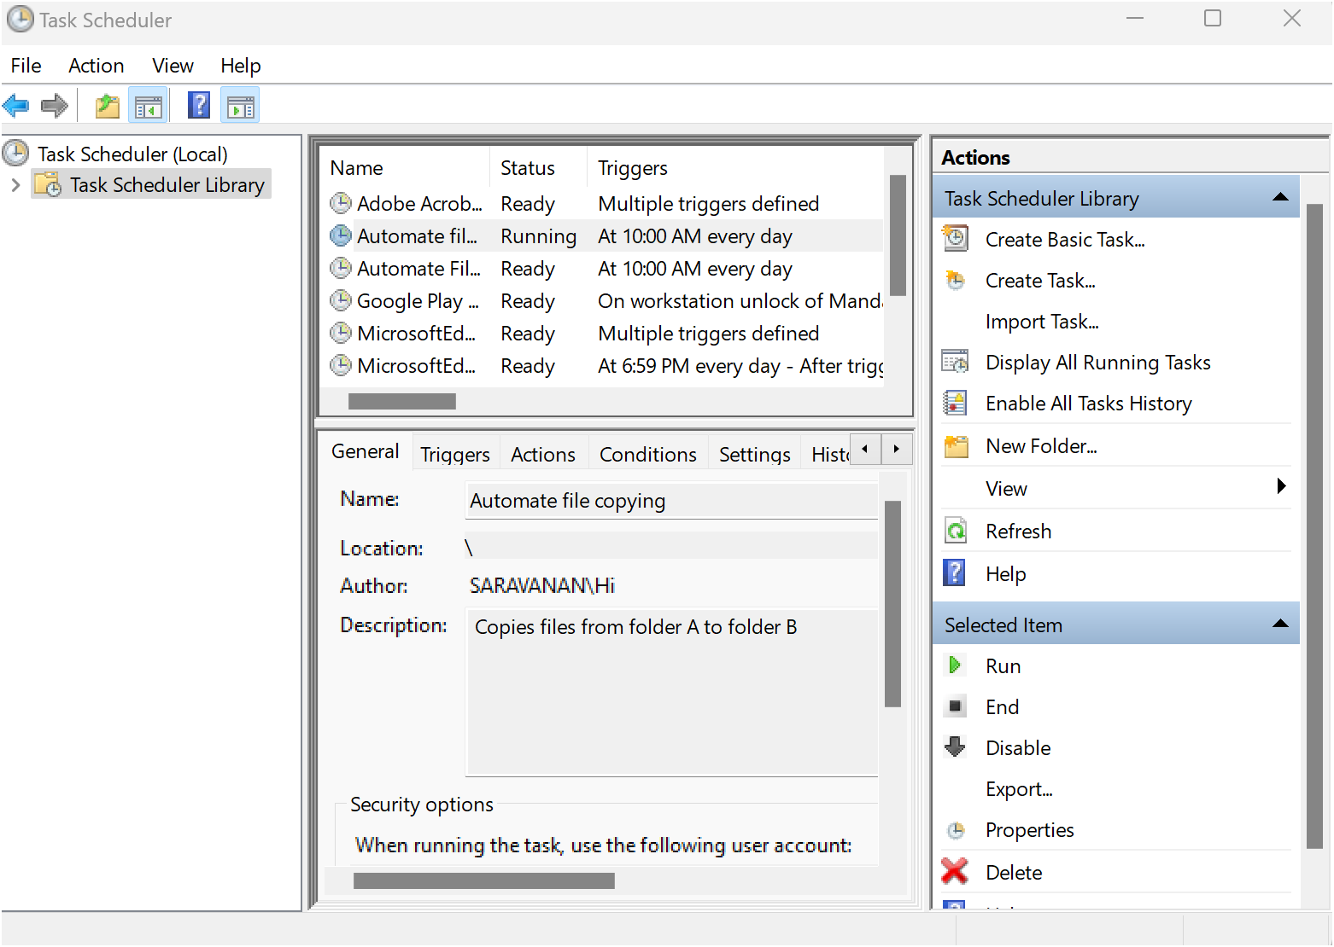

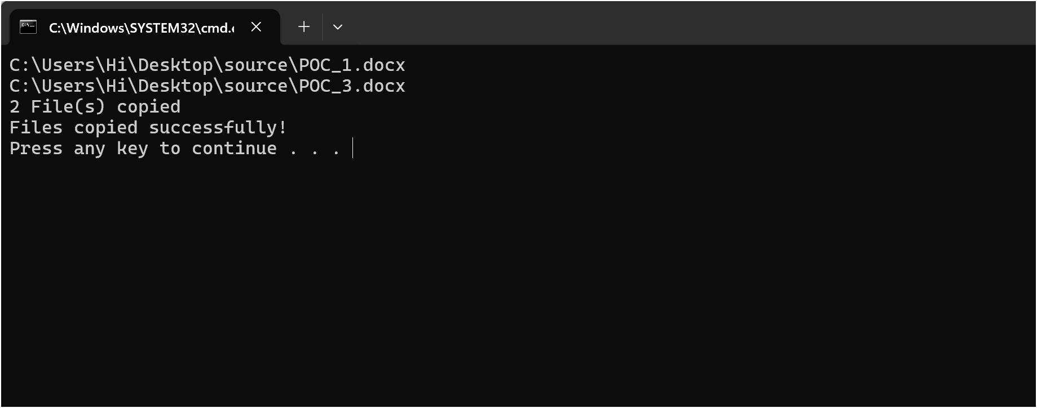

* Step 10

If your task was set up to copy files, go to the destination folder and confirm that the files have been copied.

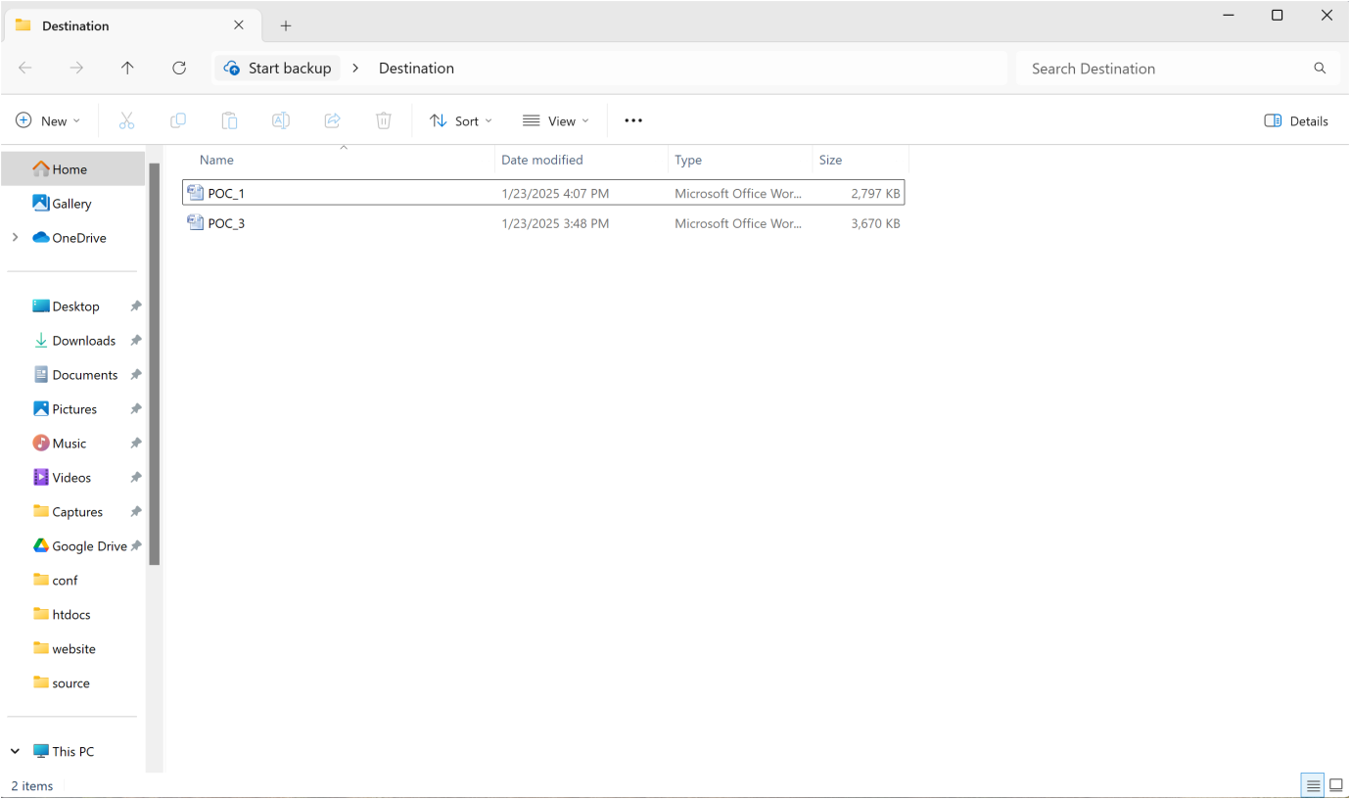

### ****Step 11: Automate Execution (Optional)****

* **Windows:** Use Task Scheduler to run the script at intervals.
* **Linux/macOS:** Use Cron Jobs (crontab -e).

## **Expected Outcome**

1. Successfully copy files from source to destination.
2. Automate file transfer using scripting.
3. Understand basic scripting and automation principles